1. **Testing Async Server** 
   1. Req 10, konkurensi 2

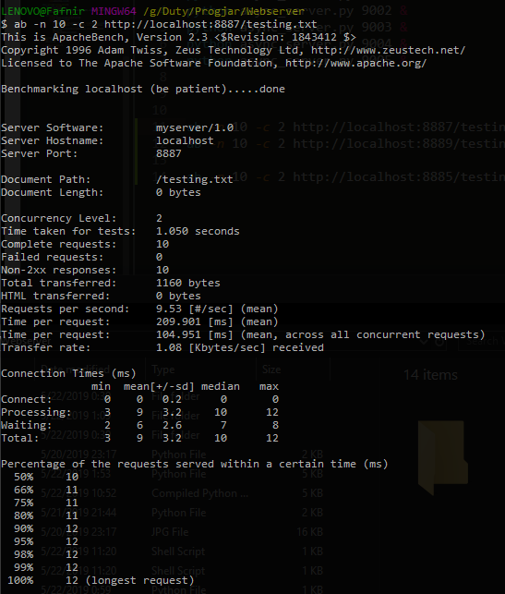

* 1. Req 50 kon 15

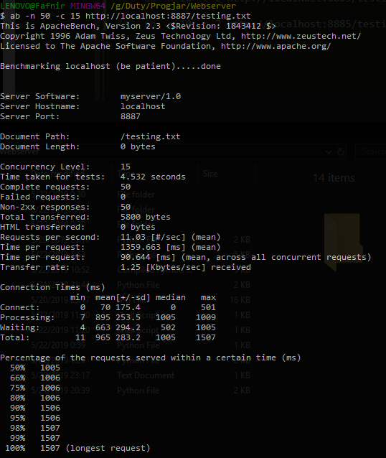

* 1. Req 100 kon 50

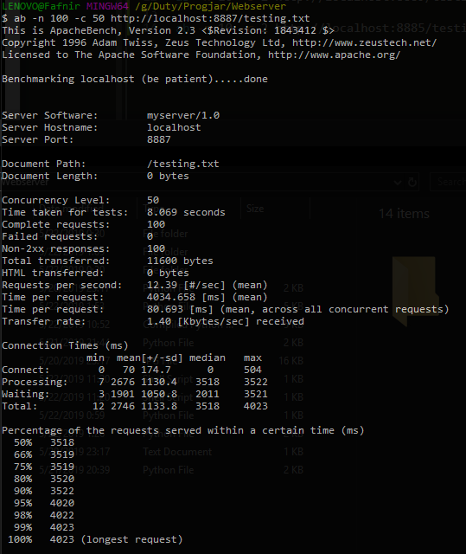

* 1. Req 1000 kon 100

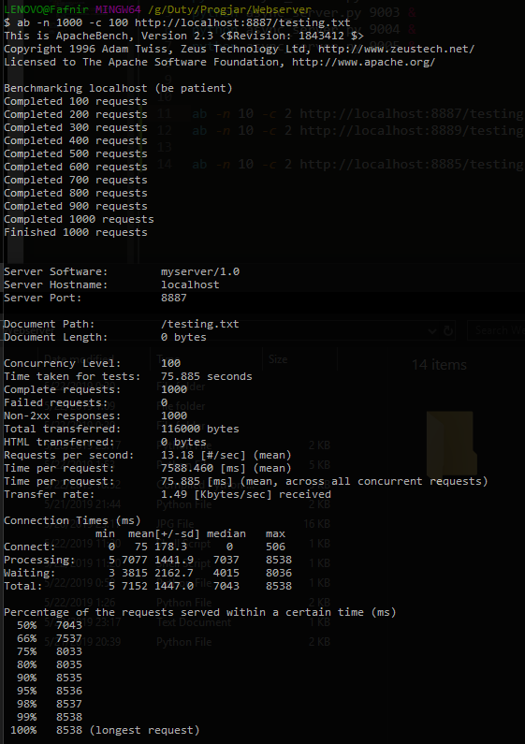

* 1. Req 10000 kon 100

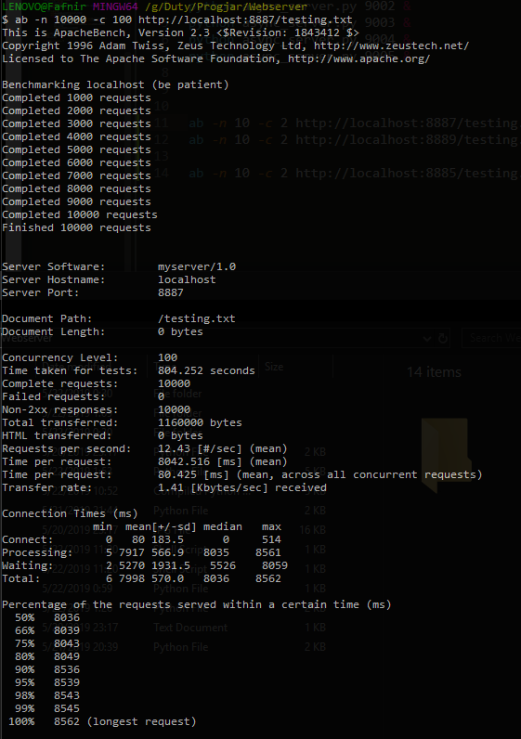

* 1. Req 20000 kon 100

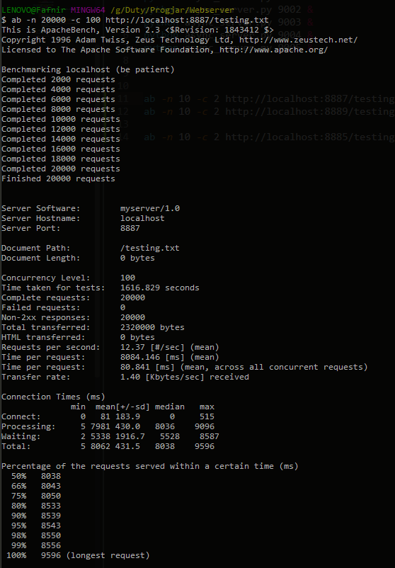

1. **Testing Async Thread**
   1. Req 10 kon 2

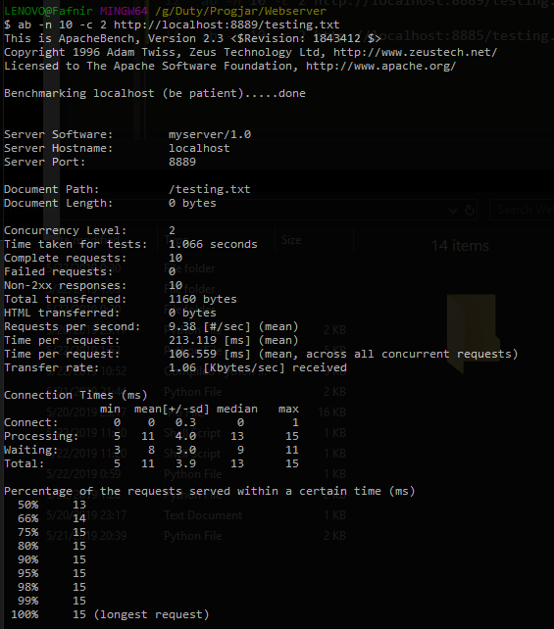

* 1. Req 50 kon 15

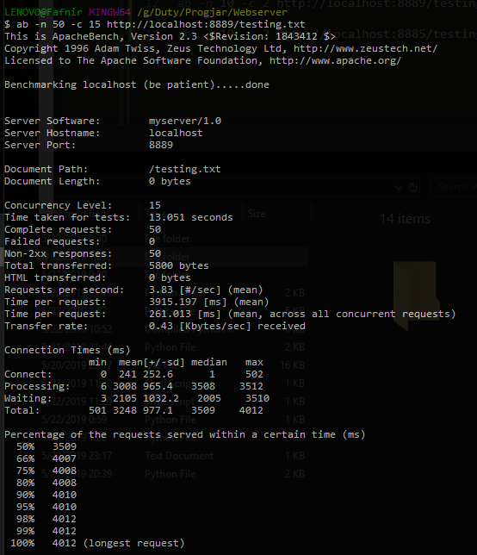

* 1. Req 100 kon 50

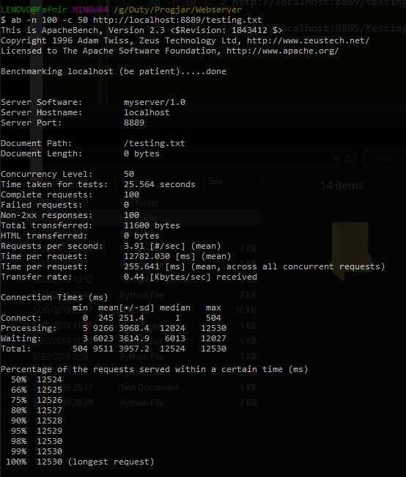

* 1. Req 1000 kon 100

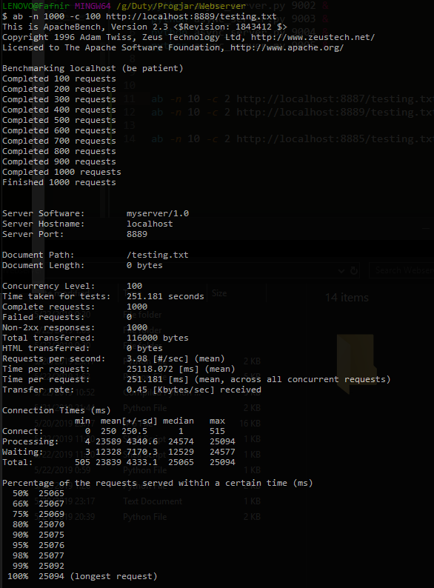

* 1. Req 10000 kon 100

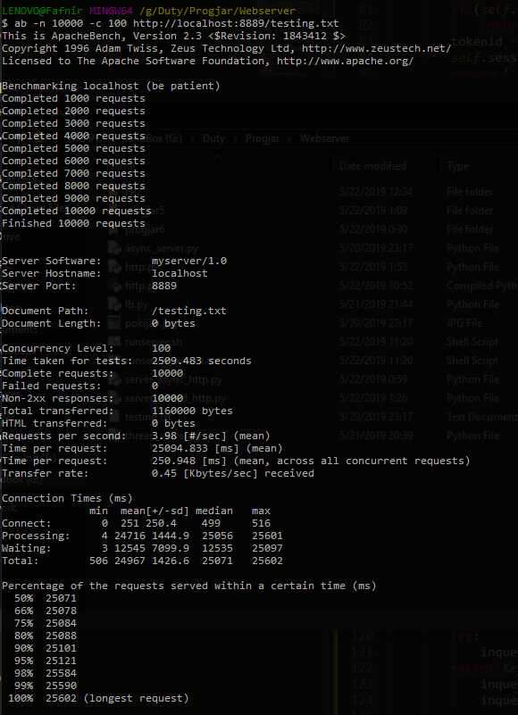

* 1. Req 20000 kon 100

1. **Testing dengan Load Balancer**
   1. Async server
      1. Req 10 kon 2

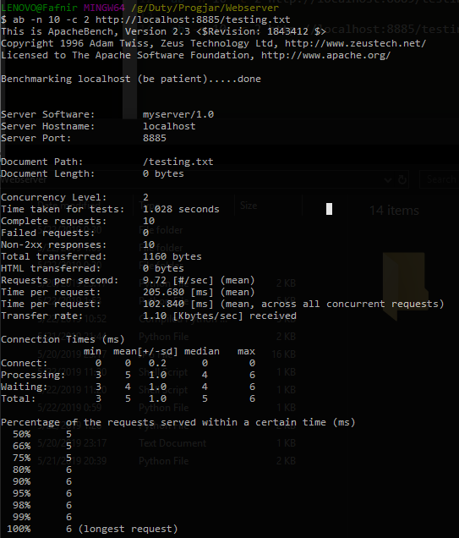

* + 1. Req 50 kon 15

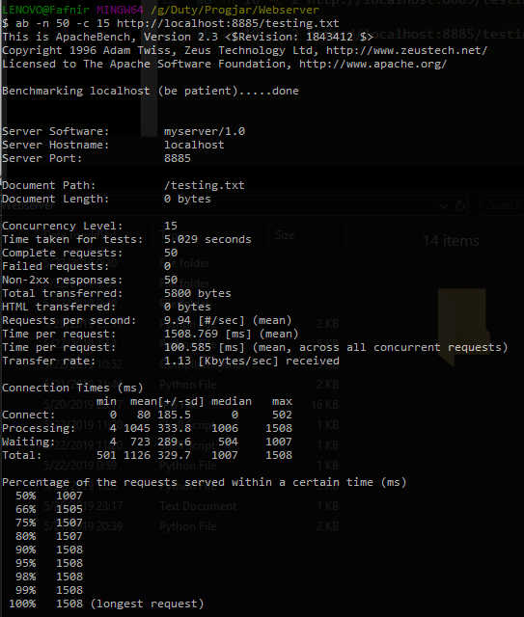

* + 1. Req 100 kon 50

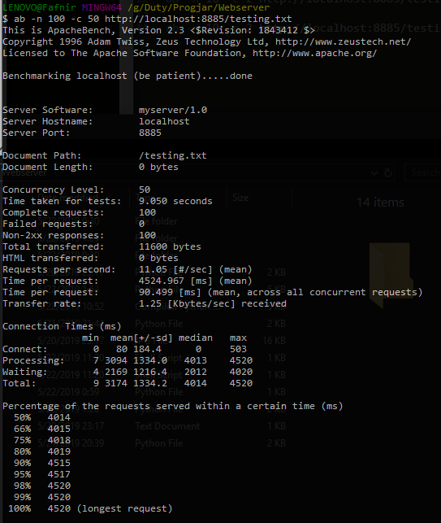

* + 1. Req 1000 kon 100

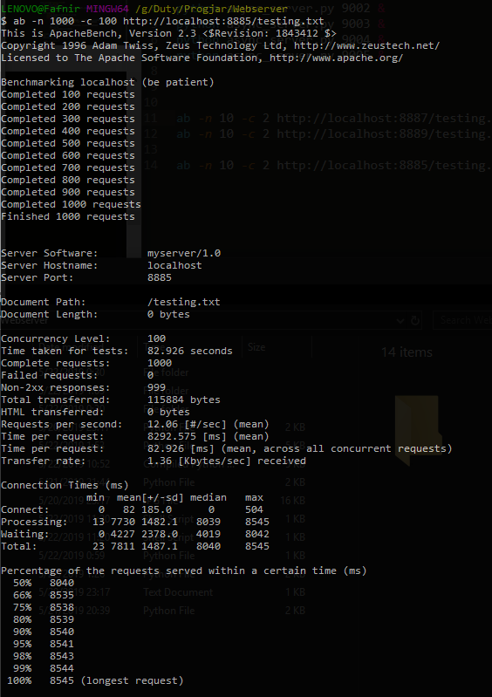

* + 1. Req 10000 kon 100

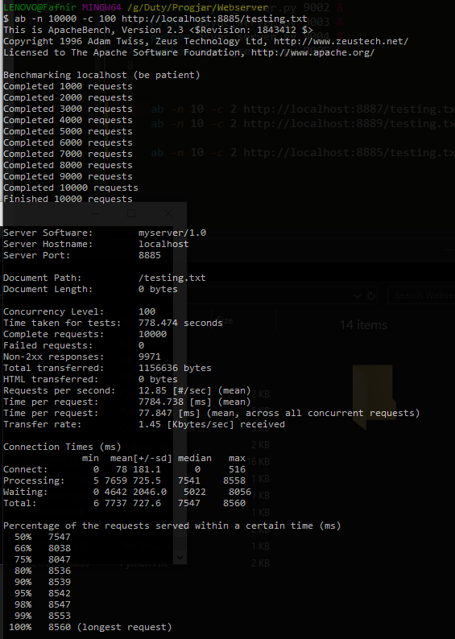

* + 1. Req 20000 kon 100
  1. Async thread
     1. Req 10 kon 2

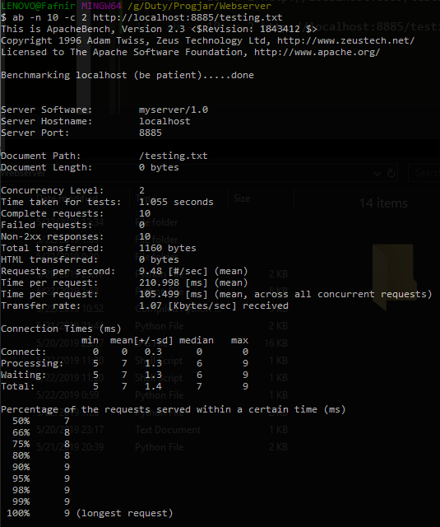

* + 1. Req 50 kon 15

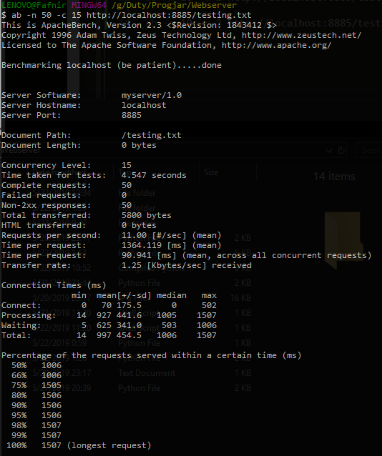

* + 1. Req 100 kon 50

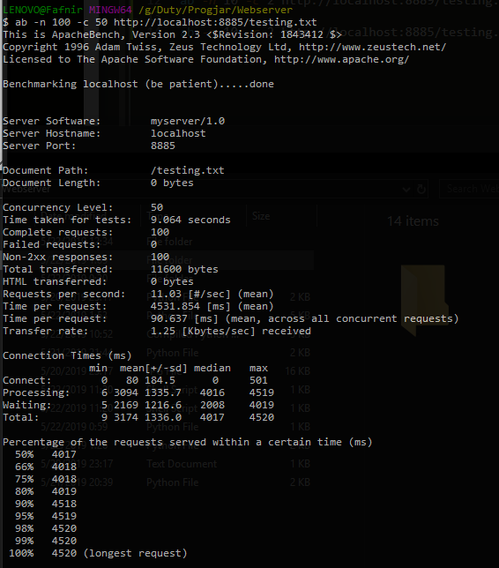

* + 1. Req 1000 kon 100

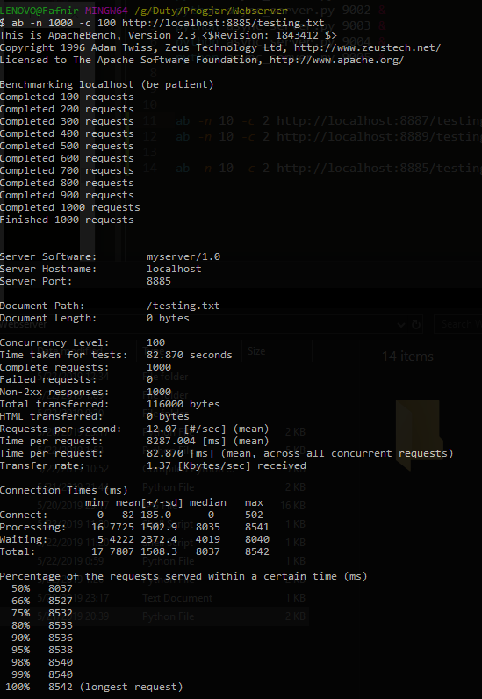

* + 1. Req 10000 kon 100

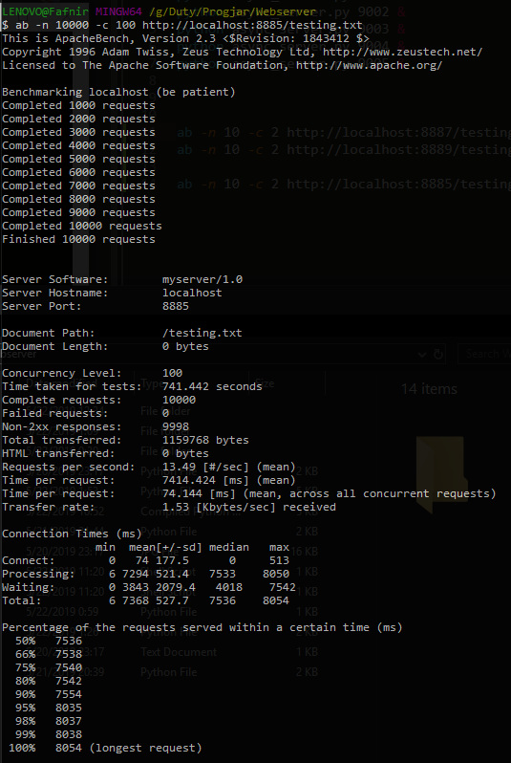

* + 1. Req 20000 kon 100

